


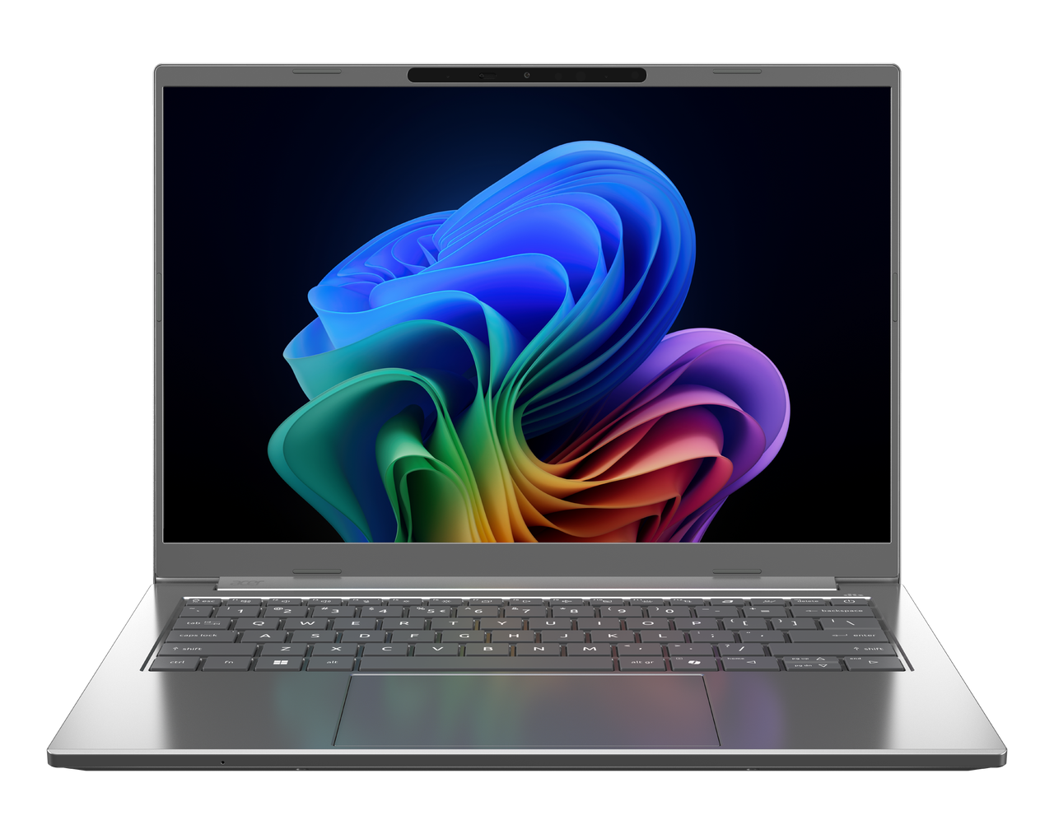

Aspire 14 AI
SPECIFICATIONS Aspire 14 AI A14-I71M, A14-I71MT
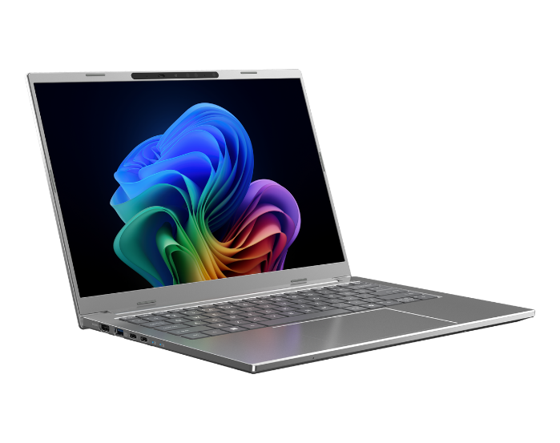
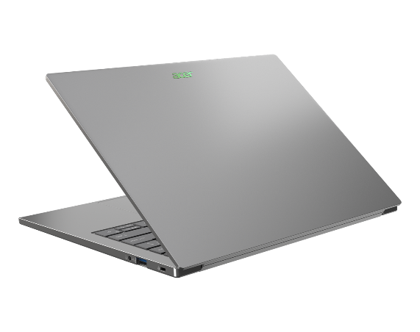
1
4
3
2
1

5
12
11
Product views | - Microphones  - Camera shutter  - Camera  - IR Camera  - Non-touch/Touch OLED Display¹  - HDMI 2.1 port  - USB 3.2  - Thunderbolt™ 4  - Thunderbolt™ 4 |  | - Touchpad  - Keyboard  - Power button  - DC-in port 20 V; 65 W  - USB 3.2  - Kensington Lock
Operating system¹ | Windows 11 Home / Pro
CPU and chipset¹ | Intel® Core™ Ultra 5 processor 322 | Intel® Core™ Ultra 5 processor 325 | Intel® Core™ Ultra 7 processor 355 | Intel® Core™ Ultra 7 processor 356H  Intel® Core™ Ultra 9 processor 386H
Memory^{1, 2, 3} | Dual-channel LPDDR5X SDRAM support  - 32 GB of onboard LPDDR5X system memory |  | Dual-channel LPDDR5X SDRAM support  - 16 GB of onboard LPDDR5X system memory
Display⁴ | A14-I71M  14.0" display with IPS (In-Plane Switching) technology, WUXGA 1920 x 1200, Acer ComfyView™ LED-backlit TFT LCD, supporting 120Hz refresh rate.  - 16:10 aspect ratio, color gamut sRGB 100%  - Wide viewing angle up to 170 degrees  - Mercury free, environment friendly |  | A14-I71MT  14.0" WUXGA 1920 x 1200 resolution LED-backlit IPS LCD with integrated multi-touch 16:10 aspect ratio, color gamut sRGB 100%  - 16:10 aspect ratio, sRBG 100%  - Super-slim design
Audio | - DTS® Audio, featuring optimized bass response and micro-speaker distortion prevention  - Acer Purified.Voice technology with AI noise reduction in a 3-mic array of built-in microphones, supporting Advanced Privacy Mode, far-field pickup, dynamic noise reduction through neural networks, adaptive beam forming, and pre-defined personal and conference call modes  - High SNR DAC with 2.1 Vrms output capability, capable of driving high-impedance headphones up to 600 ohms  - Acer TrueHarmony Technology for lower distortion, wider frequency range, headphone-like audio, and powerful sound powered by the Acer Ultra Boost Stereo Speaker Module  - Compatible with Cortana with Voice
Storage^{1, 5} | Solid state drive  - 512 GB / 1 TB, PCIe Gen4, 16 Gb/s, NVMe
Webcam¹ | Video conferencing  UFC with:  - Double T-Type USB FHD +IR Camera  - Dual Mic (33 mm + 33 mm)"  - Blue glass lens | - Compatible with Windows only  - 1920 x 1080 resolution  - 1080p HD video at 30 fps with Temporal Noise Reduction  - IR 940nm
Wireless and networking¹ | WLAN  - Intel® Wireless Wi-Fi 6E AX211  - 802.11 a/b/g/n/ac/ax wireless LAN  - Band: 2.4 GHz, 5 GHz and 6 GHz |  | - 2x2 MIMO technology  Support CNVi interface  WPAN  Supports Bluetooth® 5.4 or above `  Supports Bluetooth LE Audio (LC3).
Dimensions and weight^{6.7} | Dimensions: •312.4 (W) x 225.9 (D) x 11.6/15.8 (H) mm (12.3 x 8.89 x 0.46/0.62 inches)  Weight: •1.25 kg (2.76 lbs.) with 3-cell battery pack, one SSD
Power adapter and battery | Power adapter  3-pin 100 W PD PCR 50%, TCO 9.0 AC adapter  •5 V / 3 A or 9 V / 3 A or 12 V / 3 A or 15 V / 3 A or 20 V / 3.25 A as output power"  •108.0 (W) x 56.0 (D) x 26.5 (H) mm (4.25 x 2.20 x 1.04 inches)"  •296 g ± 5% with 150 cm DC cable  •Black color with Acer logo  •Brick type AC pins"USB Type-C 65 W PD PCR 50%, TCO 9.0 AC adapter |  | USB Type-C 65 W PD PCR 50%, TCO 9.0 AC adapter  •5 V / 3 A or 9 V / 3 A or 12 V / 3 A or 15 V / 3 A or 20 V / 3.25 A as output power  •90.0 (W) x 51.0 (D) x 28.5 (H) mm (3.54 x 2.01 x 1.12 inches)  •​192 g ± 10% with 150 cm DC cable  •Black color with Acer logo  •Brick type AC pins
Input and control | Keyboard  81-/82-/85-key Acer backlight keyboard layout with multiple international language support, SR03P  •Enlarged keycaps for better type feeling  •Optimal backlight brightness for better ligibilty  •Quiet & silent design for noise-reduction  •Indicators of CapsLock and Microphone mute toggle indicators  •Function lock for user's hot-key preference  Touchpad  - Multi-gesture touchpad, supporting two-finger scroll; pinch; gestures to open Cortana, Action Center, multitasking; application commands  - Microsoft Precision Touchpad certification |  | - Moisture resistant  Control Keys  - Programmable key – my key  - Acer Sense Key  - Copilot Key
Windows Desktop Apps⁸ | Acer AI Image Generator  Acer AlterView  Acer LiveArt  Acer ORD Service |  | Acer QuickPanel  Acer VisionArt  AcerSense  Acer My Key Application
Warranty | One-year International Travelers Warranty (ITW)
1. Specifications vary depending on model.
2. Shared system memory may be allocated to support graphics, depending on system memory size and other factors. Actual system memory available to the operating system will be reduced by any memory used by the graphics solution and resources required by the operating environment.
3. Memory speed may vary, depending on the CPU, chipset or memory fitted.
4. All brands and product names mentioned herein include trademarks of their respective companies and are used solely to describe or identify the products.
5. 1 GB is 1 billion bytes. Actual formatted capacity is less and may vary depending on preloaded materials and operating environment. Acer Recovery Management uses a portion of the stated hard disk capacity as dedicated backup space.
6. Minor variations in system dimensions are possible due to the manufacturing process.
7. Weight may vary depending on product configuration, vendor components, manufacturing variability, and selected options.
8. Bundled software may vary depending on hardware configuration, OS and regional availability.

Note: This specification is based on Aspire A14-I71M Specifications (v1-0-0) (Preview),Aspire A14-I71MT Specifications (v1-0-0) (Preview)

15
14
13
7
9
8
6
101

